Hello!

Are you looking for ideas for your next project with young people?

We offer our staple Graffiti, Urban Fashion and Sneaker Customisation workshops, as well as our newest 3D-Graffiti and Graffiti Collage! All great on their own and even better when combined!

We also provide training in Web Design and Photoshop, which you can combine with any of the workshops. Mixing traditional and digital techniques, young people can use an even wider range of media to work on their garments or canvases, digital and crafts.

All the details are below in this brochure, but we’d like to hear from you, so please get in touch and let’s talk about those amazing workshops you’ve always wanted to provide for your young people. Remember we are really flexible in terms of materials and length of our programmes, from a few hours to ongoing projects, so we can guarantee that we can accommodate to your budget, whatever it is. From small workshops to large-scale community projects, count on us for delivery.

With our best wishes,  The OTL Team.  www.onthelevelproductions.co.uk  hello@onthelevelproductions.co.uk |  |  | 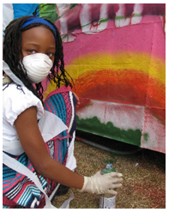
 |  |  |  | 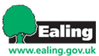 | 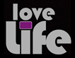
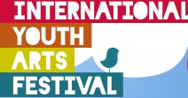 |  | 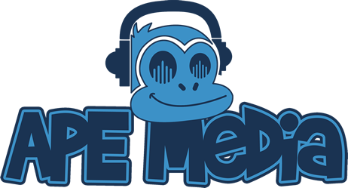 |  |  | 
 |  | 

Graffiti/Street Art Workshop
Consists on engaging with a group of young people to create a collaborative mural which theme can be previously agreed, using spray cans, stencils and other techniques used in urban art. The mural can be done onto a wall, boards or large canvas, and can be used for display purposes or as backdrop for other activities. The main objectives are as follows:
1) Give the young people an introduction to the modern art of Graffiti, from its origins in the early 80s until now, through photographs, videos, etc.

2) Completion of a collaborative mural, emphasizing on teamwork.
3) Bring the subject to a Q/A session, where the topic can be discussed, focusing on the differences between illegal and responsible art, as well as its effect on the local community.
4) Engage with the participants to create a series of designs and sketches of their own, making them aware of their own capabilities and exposing them to a different array of materials.
5) Work with them to apply these designs onto the murals.
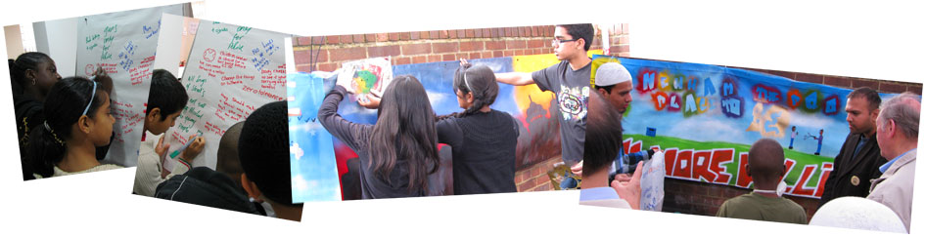
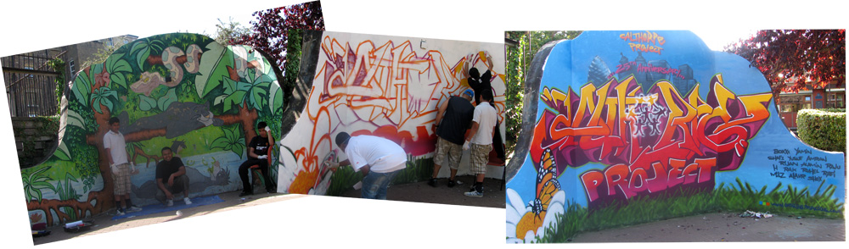
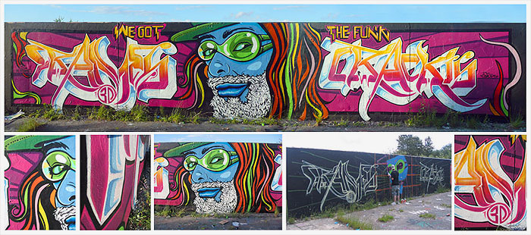

3D Graffiti Workshop
Much like our staple Graffiti workshop, but “in-depth”!

What is 3D Graffiti???

Graffiti is commonly known as art executed on walls or other flat surfaces. We take this concept further by uniquely offering a 3D version, where the mural is executed on card boxes and other recycling materials that form a structure, giving the artwork full height, width and depth. Here is an example, a radio sound system executed on card boxes, forming a free-standing artwork:

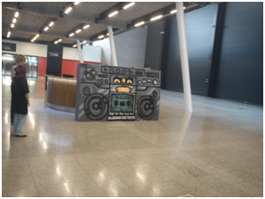 | 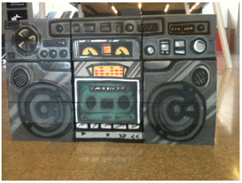

The main objectives are:

- Give the young people an introduction to the modern art of Graffiti, through photographs, videos, etc. and the execution of a collaborative artwork, emphasizing on team work.

- Bring the subject to a Q/A session, where the topic can be discussed, focusing on the differences between illegal and responsible art.

- Engage with the participants to create a series of designs and sketches of their own, making them aware of their own capabilities and exposing them to a different array of materials.

- Work with them to apply these designs onto the artwork

- Experiment with DYI and building techniques, when creating the structure

- Raise recycling awareness by utilising waste materials (card boxes etc) to create the structure

Urban Fashion Workshop

Fashion is another great way to engage with young people and in this workshop our mentors assist them in customizing garments such as t-shirts, caps, cotton bags or any other garment using a variety of media such as acrylics, fabrics, jewellery, spray paints, stencils and markers.
The workshop typically concludes with a catwalk where the young designers showcase their creations, all family and friends invited!
The main objectives are as follows:
1) Give the young people the opportunity to create their own designs, which will then wear.
2) Exposing them to a different array of materials and make them aware of their own capabilities

3) Focus on the fact that they can create fashionable items at home with simple everyday items that don't cost that much.
4) Work with them to apply their own ideas onto the garments.
5) Push their own boundaries and boost their self-esteem by overcoming their fears when showing their creations on the catwalk.

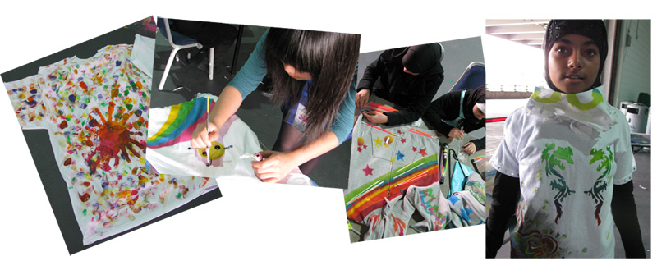

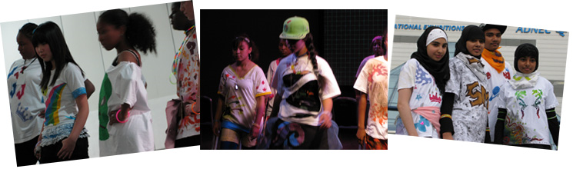

Graffiti Collage
Sometimes it is not possible to use spray paint, especially when indoors or when the young people are too young to hold the cans, or have special disabilities. Or perhaps they want to be extra creative!

Graffiti Collage consists on creating a graffiti mural, but using fabrics and other materials to actually give shape and colour to the artwork, as opposed to spray paint. Still done over a large canvas, the final piece can be stored and displayed however you like.

Sneaker Customisation Workshop

Very similar to the Urban Fashion, in this workshop our mentors help the young people customize their own trainers using some special durable stickers that can be painted and customized, and then put over their trainers. These stickers are made of a special material that although durable, is very easy to peel off. This way the young designers don't risk ruining their shoes!

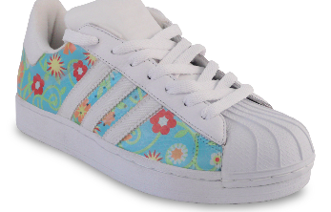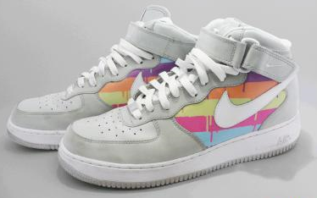

Mix’em all up!

We know, it’s hard to decide… Do them all at once! You can pick and choose and completely tailor the workshops they way you want it. For example, we can provide a Graffiti Workshop where the young people can work on a big mural and also on some t-shirts to take home. Or perhaps Urban Fashion combined with Street Dance so they get to customize their own outfits for their dance routine…
How about a large graffiti piece to use as backdrop for the street dance show?

The possibilities are endless and our workshops are totally flexible in terms of activities, duration, materials and number of young people attending.

Get in touch and tell us about your project, we’ll work with you to deliver the perfect workshop.

Now booking!

For more information and some examples of previous work, please visit us at www.onthelevelproductions.co.uk

For all enquiries or just to say hello, contact us at
hello@onthelevelproductions.co.uk

OnTheLevel Productions, Conscious Workshops

OnTheLevel Productions Ltd. | Registered in England and Wales No. 7038957



